Options submitted for the west end of the Tallington Bypass Route - by 31st July 2019
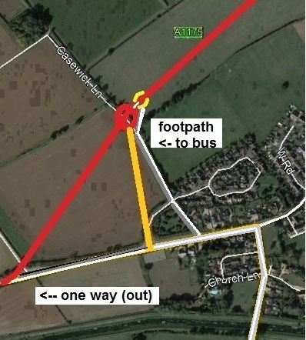  1. Proposal made by Ken Otter | 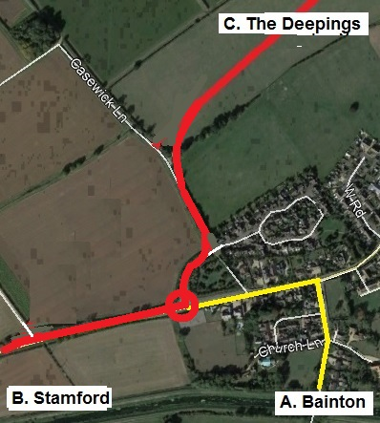  2. Verbal submission by Geoff Sutcliffe
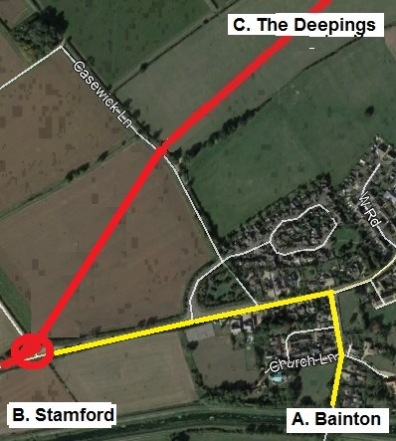  3. Written proposal by John Smith & Philip Sagar | 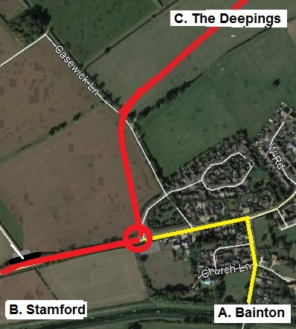  4. Verbal suggestion from Pauline Horrocks
Ken's comments:
1. Provides a smooth flow onto the bypass matching the Deepings end, once on, they stay on!
Minimises sat-nav errors and HGV's coming through the village and having to turn round!
Minimises distance for anyone in the village or from Bainton Road going to or from The Deepings.
Minimises disruption for villagers going to Stamford. Provides HGV access to and from The Pheasantries
Keeps all high speed traffic and noise away from populated areas, leaving development possibilities.
Provides a pleasant walk to and from the bus stop and provides a good road exit towards Stamford.

2. The worst of all options. HGV's and other traffic go straight on and have to turn round!
Noisy polluting traffic close to houses, less options for future development.
No provision for safe HGV access to and from The Pheasantries

3. Again, HGV's and other traffic on sat-nav go straight on and have to turn round!
Maximum inconvenience for residents (and Bainton Road traffic) going across towards The Deepings.
Again, no provision for safe HGV access to and from The Pheasantries

4. Again, HGV's and other traffic on sat-nav go straight on and have to turn round!
Again, no provision for safe HGV access to and from The Pheasantries

